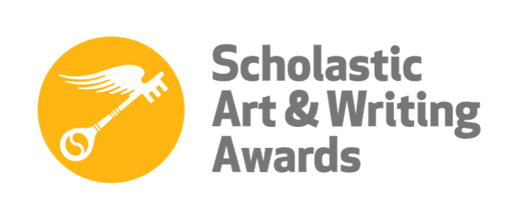
NYC 2016 Scholastic Art Awards
American Visions Nominees

Choi, Harim
Category: Sculpture

Jorgl, Jake
Category: Drawing and Illustration

Nodel Kishner, Mikhaila
Category: Mixed Media

Potter, Sophie
Category: Photography

Winter, Phillip
Category: Fashion

