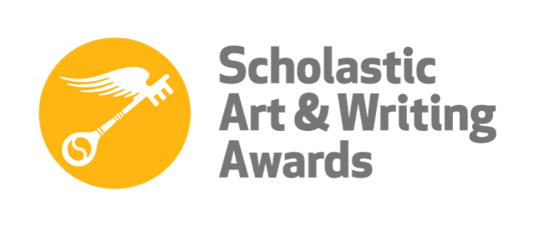
NYC 2016 Scholastic Writing Awards
American Voices Nominees

Benzizoune, Romaissaa
Category: Poetry

Benzizoune, Romaissaa
Category: Short Story

Chen, Karen
Category: Personal Essay/Memoir

Healey, Luisa
Category: Personal Essay/Memoir

Lin, Janni
Category: Personal Essay/Memoir

